Control Systems Lab

Lab 3 Submission: Frequency Response

Objectives
- Use experimental data to estimate magnitude and phase shift for different frequencies
- Plot experimental frequency response data for the DC motor in a bode plot format
- Compare experimental data to the bode plot predicted from model obtained in Lab 2

Experimental frequency response
- Using the method from the Lab In-Class session, plot the input and output data of each frequency you collected and use the plot to estimate magnitude and phase shift.

  - For each frequency tested, show a screenshot of the plotted data includes the exact data points you will use for the calculations below using Data Tips.

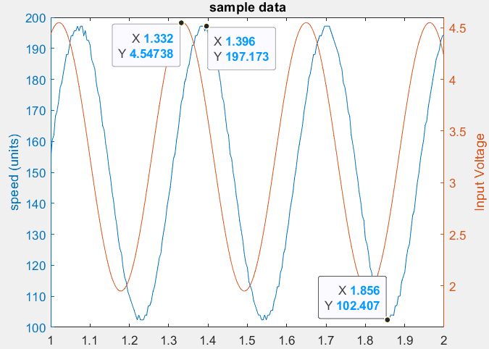
Figure 1: Example: data tips used for calculations

Plots for each tested frequency

1.2 For one of these frequencies (not 30 rad/sec), show the work you used to calculate magnitude and phase. Please note your work must use the exact data points shown on the Data Tips from your plotted data. You will not receive credit if you do not use your exact data points from your data.
Work to obtain magnitude and phase for one of the frequencies

1.3 Summarize the full set of data in the table below.
Frequency (Rad/s) |  | Magnitude (Rad/s/V) | Magnitude (dB) | Time shift (s) | Phase (Degrees)

Predicted bode diagram
- Derive the analytical frequency response from the model based on Lab 2. This includes an expression for magnitude and an expression for phase. Use typical values of steady-state gain, $K=65$ (rad/sec)/volt and time constant $τ=0.0603$ seconds.
Work to find magnitude and phase
- Plot this analytical frequency response in a bode diagram format, using the sample code provided on Blackboard. Include a screenshot of your code.
Your code here

Comparison
- Plot the experimental data on top of the predicted bode diagram, using the sample code provided on Blackboard. Show a screenshot of your plot, properly annotated with your name in the title.
plot

Conclusions
- Which graphs match better in general - Magnitude or Phase? What frequencies does the data tend to match better - lower or higher?

- The microprocessor used in the lab has a sampling time of 0.005 second (a delay). Using the formula to convert a time shift to an angle, calculate additional phase shift caused by the microprocessor delay at a frequency of 100 rad/sec. Discuss how this relates to the difference between experimental and predicted phase observed in question 5.

